User Acceptance Testing (UAT) Template
Book a Doctor — Online Doctor Appointment Booking System
Date | 19 July 2026
Team ID
Project Name | Book a Doctor
Maximum Marks

Project Overview
Project Name: Book a Doctor
Project Description: A MERN-stack (MongoDB, Express.js, React.js, Node.js) web application that lets patients search for doctors, book and manage appointments, pay online, and lets doctors and admins manage schedules, profiles, and records.
Project Version: v1.0 | Testing Period: 01 July 2026 to 18 July 2026

Testing Scope
- Patient registration, login, and profile management
- Doctor search, filtering, and profile viewing
- Appointment booking, rescheduling, and cancellation
- Online payment for consultations
- Doctor dashboard for managing appointments
- Admin dashboard for managing doctors, patients, and platform data
- Email/SMS notifications for booking confirmations and reminders

Testing Environment
URL/Location: https://staging.bookadoctor.example.com
Credentials: Test accounts provided separately for Patient, Doctor, and Admin roles.

Test Cases
ID | Scenario | Steps | Expected Result | Actual Result | Result
TC-001 | Register with valid email & password | Open Register → enter valid details → Submit | Account created; redirected to login with success message | Account created and redirect worked as expected | Pass
TC-002 | Cannot register with used email | Open Register → enter existing email → Submit | Error: 'Email already registered' | Correct error message displayed | Pass
TC-003 | Search doctors by specialty | Login → Find Doctors → select 'Cardiology' filter | List shows only cardiologists, sorted by availability | Filter worked; sort order matched availability | Pass
TC-004 | Book an available slot | Select doctor → pick open slot → Confirm | Slot booked, marked unavailable, confirmation shown | Booking confirmed; slot updated in real time | Pass
TC-005 | Cannot double-book same slot | Two patients select same slot simultaneously → both confirm | Only first request succeeds; second gets 'Slot no longer available' | Second request correctly blocked with error | Pass
TC-006 | Doctor views upcoming appointments | Login as Doctor → open Dashboard | List of upcoming appointments with patient name & time | Dashboard displayed correct appointment list | Pass
TC-007 | Admin deactivates a doctor profile | Login as Admin → Doctor Management → Deactivate | Doctor hidden from patient search; record retained | Doctor hidden from search; record retained in DB | Pass
TC-008 | Payment fails gracefully on declined card | Book appointment → enter declined test card → Submit | Clear decline message shown; booking not confirmed | Decline message shown, but wording unclear to test users | Fail

Test Execution Summary
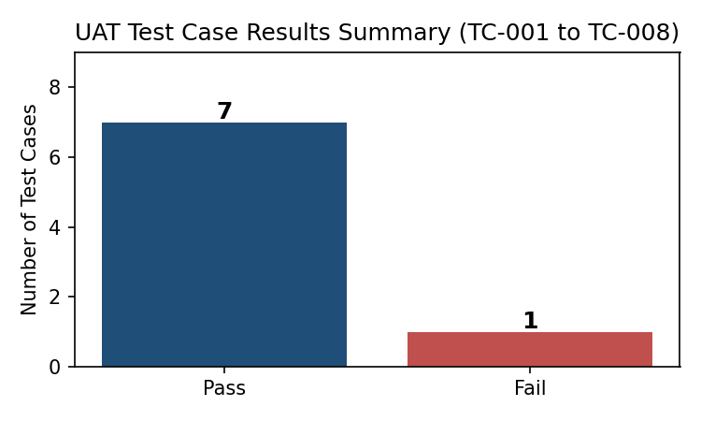
Fig. 1 — Result summary across all 8 executed test cases (7 Pass, 1 Fail)

Bug Tracking
Bug ID | Description | Steps to Reproduce | Severity | Status | Additional Feedback
BG-001 | Decline-message wording on failed payment is unclear to users | Book appointment → use declined test card → Submit payment | Medium | Open | Suggest plain-language message: 'Payment declined by your bank — please try another card.'
BG-002 | Reschedule confirmation email delayed by ~5 seconds | Reschedule an existing appointment → check inbox | Low | In Progress | Not urgent, but worth checking the email queue/worker under load.

Sign-off
Tester Name: ___________________________ Date: 18 July 2026
Signature: ___________________________

